Family doctor services registration GMS1

Patient’s details |  |  |  |  |  |  |  |  |  | Please complete in BLOCK CAPITALS and tick | as appropriate
Mr |  | Mrs |  |  |  | Miss |  |  | Ms | Surname
Date of birth |  |  |  |  |  |  |  |  |  | First names
NHS |  |  |  |  |  |  |  |  |  | Previous surname/s
No.
 |  |  |  |  |  |  |  |  |  | Town and country
Male |  |  | Female
 |  |  |  |  |  |  |  |  |  | of birth
Home address
Postcode |  |  |  |  |  |  |  |  |  | Telephone number

Please help us trace your previous medical records by providing the following information

Your previous address in UK |  | Name of previous GP practice while at that address
 |  | Address of previous GP practice

If you are from abroad

Your first UK address where registered with a GP

If previously resident in UK, | Date you first came
date of leaving | to live in UK

Were you ever registered with an Armed Forces GP

Please indicate if you have served in the UK Armed Forces and/or been registered with a Ministry of Defence GP in the

UK or overseas: | Regular | Reservist | Veteran | Family Member (Spouse, Civil Partner, Service Child)
Address before enlisting:
 |  |  |  | Postcode
Service or Personnel number: |  |  | Enlistment date: DD MM YY Discharge date: DD MM YY (if applicable)

Footnote: These questions are optional and your answers will not affect your entitlement to register or receive services from the NHS but may improve access to some NHS priority and service charities services.

If you need your doctor to dispense medicines and appliances*
*Not all doctors are

I live more than 1.6km in a straight line from the nearest chemist |  | authorised to
I would have serious difficulty in | getting them from a chemist | dispense medicines
Signature of Patient | Signature on behalf of patient

Date________/_________/_________

NHS Organ Donor registration

I want to register my details on the NHS Organ Donor Register as someone whose organs/tissue may be used for transplantation after my death. Please tick the boxes that apply.
Any of my organs and tissue or

Kidneys | Heart | Liver | Corneas | Lungs | Pancreas
Signature confirming my consent to join the NHS Organ Donor Register |  |  |  |  | Date ________/________/________

Please tell your family you want to be an organ donor. If you do not want to be an organ donor, please visit www.organdonation.nhs.uk or call 0300 123 23 23 to register your decision.

NHS Blood Donor registration

I would like to join the NHS Blood Donor Register as someone who may be contacted and would be prepared to donate blood. Tick here if you have given blood in the last 3 years

Signature confirming my consent to join the NHS Blood Donor Register Date ________/________/________

My preferred address for donation is: (only if different from above, e.g. your place of work) Postcode:
All blood types are needed, especially O negative and B negative. Visit www.blood.co.uk or call 0300 123 23 23.

NHS England use only |  | Patient registered for | GMS | Dispensing
052019_006 | Product Code: GMS1

GMS1_112018_005 Family Doctor Services Registration_tearoff.indd 1 27/06/2019 15:08
 |  |  | Family doctor services registration
 |  |  |  |  | GMS1
 |  | To be completed by the GP Practice
 |  | Practice Name |  | Practice Code

I have accepted this patient for general medical services on behalf of the practice

I will dispense medicines/appliances to this patient subject to NHS England approval.

I declare to the best of my belief this information is correct |  | Practice Stamp
Authorised Signature
Name | Date _______/_______/_______

SUPPLEMENTARY QUESTIONS QUESTIONS - These questions and the patient declaration are optional and your answers will not affect your entitlement to register or receive services from your GP.

PATIENT DECLARATION for all patients who are not ordinarily resident in the UK

Anybody in England can register with a GP practice and receive free medical care from that practice.

However, if you are not ‘ordinarily resident’ in the UK you may have to pay for NHS treatment outside of the GP practice. Being ordinarily resident broadly means living lawfully in the UK on a properly settled basis for the time being. In most cases, nationals of countries outside the European Economic Area must also have the status of ‘indefinite leave to remain’ in the UK.

Some services, such as diagnostic tests of suspected infectious diseases and any treatment of those diseases are free of charge to all people, while some groups who are not ordinarily resident here are exempt from all treatment charges.

More information on ordinary residence, exemptions and paying for NHS services can be found in the Visitor and Migrant patient leaflet, available from your GP practice.

You may be asked to provide proof of entitlement in order to receive free NHS treatment outside of the GP practice, otherwise you may be charged for your treatment. Even if you have to pay for a service, you will always be provided with any immediately necessary or urgent treatment, regardless of advance payment.

The information you give on this form will be used to assist in identifying your chargeable status, and may be shared, including with NHS secondary care organisations (e.g. hospitals) and NHS Digital, for the purposes of validation, invoicing and cost recovery. You may be contacted on behalf of the NHS to confirm any details you have provided.

Please tick one of the following boxes:

a) I understand that I may need to pay for NHS treatment outside of the GP practice

b) | I understand I have a valid exemption from paying for NHS treatment outside of the GP practice. This includes for

example, an EHIC, or payment of the Immigration Health Charge (“the Surcharge”), when accompanied by a valid visa. I can provide documents to support this when requested

c) I do not know my chargeable status

I declare that the information I give on this form is correct and complete. I understand that if it is not correct, appropriate action may be taken against me.

A parent/guardian should complete the form on behalf of a child under 16.

Signed: |  | Date: | DD MM YY
Print name: |  | Relationship to
On behalf of: |  | patient:
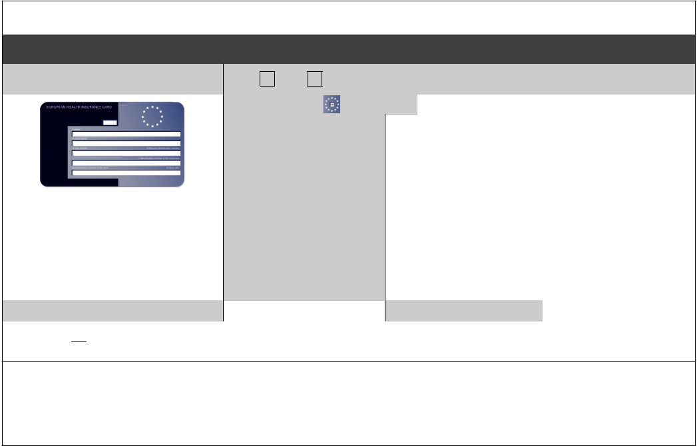

Complete this section if you live in another EEA country, or have moved to the UK to study or retire, or if you live in the UK but work in another EEA member state. Do not complete this section if you have an EHIC issued by the UK.

NON-UK EUROPEAN HEALTH INSURANCE CARD (EHIC), PROVISIONAL REPLACEMENT CERTIFICATE (PRC)

DETAILS and S1 FORMS

Do you have a non-UK EHIC or PRC? |  |  | YES: | NO: | If yes, please enter details from your EHIC or
 |  |  |  |  | PRC below:
 |  |  | Country Code:

 |  | 3: Name
 |  | 4: Given Names
 |  | 5: Date of Birth | DD MM YYYY
 |  | 6: Personal Identification
If you are visiting from another EEA |  | Number
country and do not hold a current |  | 7: Identification | number
EHIC (or Provisional Replacement |  | of the institution
Certificate (PRC))/S1, you may be billed
 |  | 8: Identification | number
for the cost of any treatment received
 |  | of the card
outside of the GP practice, including
at a hospital. |  | 9: Expiry Date | DD MM YYYY
PRC validity period | (a) From: | DD MM YYYY | (b) To: | DD MM YYYY

Please tick if you have an S1 (e.g. you are retiring to the UK or you have been posted here by your employer for work or you live in the UK but work in another EEA member state). Please give your S1 form to the practice staff.

How will your EHIC/PRC/S1 data be used? By using your EHIC or PRC for NHS treatment costs your EHIC or PRC data and GP appointment data will be shared with NHS secondary care (hospitals) and NHS Digital solely for the purposes of cost recovery. Your clinical data will not be shared in the cost recovery process.

Your EHIC, PRC or S1 information will be shared with The Department for Work and Pensions for the purpose of recovering your NHS costs from your home country.

BURNLEY GROUP PRACTICE

BENZODIAZEPINES/OPIATE ZERO TOLERANCE POLICY

GP: Al-Amin, Dr. Alvi, Dr. Arshid, Dr.Clarke, Dr. Daly, Dr.Lane, Dr. McGrogan,
Dr. Patel, Dr.Sapawi, Dr.Wilkinson,

New Patient Registration – Information for Patients prescribed long-term Hypnotics

Drugs such as Benzodiazepines (Temazepam, Nitrazepam, Loprazolam, Diazepam and Lormetazepam) and Z drugs (Zopiclone, Zolpidem and Zaleplon) are only licensed for short term use. These medicines are not routinely on REPEAT prescriptions.

This GP surgery routinely implements reduction programmes for patients of the surgery who have been on long term use of these hypnotics.

In line with this practice policy, the GP surgery will start a reduction programme for any newly registered patients who have been on these hypnotic’s long term, unless they fall into one of the following categories:

• patients with severe mental health problems under care of a psychiatrist

• on benzodiazepines for treatment of epilepsy

• seriously or terminally ill patients

To register with the GP surgery, you will have to agree to commence a reduction programme, unless you fall into one of the categories above.

Burnley Group practice has an opiate prescribing policy which involves an initial review with a clinician, to assess if the prescription is appropriate. Opiate medication (Tramadol, Fentanyl, Oxycodone, Codeine, Dihydrocodeine, Morphine, Buprenorphine, Pregabalin and Gabapentin) will be reviewed and assessed regularly. If the clinician feels it is appropriate to initiate a reduction, this will be actioned as part of the opiate policy.

To register with the GP surgery, you are agreeing to commence a reduction plan if applicable.

Patient Signature:

Date:

NEW PATIENT REGISTRATION FORM 16+
All information will be treated in the strictest confidence and is for your GP’s records only

Surname: |  | Forename: |  |  | Previous Names:
Address: Postcode:
Date of Birth:
Home Telephone Number: |  | Mobile Number: |  |  | Work Telephone Number:
Number of children: |  |  |  | Number of children living with you:
Email Address:
Are you a Carer for someone (if so who)? |  |  |  | Does someone look after you (if so who)?
Country of origin/ethnicity: |  | First Language: |  |  | Occupation:
Please tick one of the following as appropriate
Single | Married |  |  | Co-habiting |  | Widowed
FAMILY HISTORY Have you or your family had any of the following conditions?
 | Yourself |  |  | Your family – Please state family member, eg mother,  Brother, etc and give any relevant details
 | Yes |  | No
Asthma
Diabetes
High blood pressure
Heart problems
Stroke
Epilepsy/fits
Skin disorders
Nervous disorders
Allergies (inc medicines)
Congenital diseases
Cancer
Have you had any illness/operations not mentioned above? (Please give dates where applicable).
Also state if you have any special handicaps

Do you take any medicines/tablets regularly? If so, give details, ie name, dose, time of day taken

Has your blood pressure been checked in the last year? YES / NO (Please delete as appropriate)
How many times do you exercise in one week, eg walking, exercise classes, swimming, other:
Please state what immunisations you have had and when:

Do you require a health check? YES / NO (Please delete as appropriate)
The Practice Nurse may decide it would be beneficial for you to have a health check and will contact you as necessary.

THE FOLLOWING QUESTIONS MUST BE ANSWERED - Registration cannot be accepted unless this information is provided

Burnley Group Practice

U N I T S | Pint of Regular Beer/ Lager/ Cider  = 2.3 units | Alcopop or can of Lager  =1.5 units | Glass of 12%Wine (175ml)  =2.1 units | Single measure of spirit  =1 unit | Bottle of Wine  =9 units

Fast Alcohol Screening Test (FAST)
Scoring System  Questions 0 1 2 3 4 |  |  |  |  |  | Your  Score
How Often do you have 8 (men) / 6 (women) or more drinks on one occasion? | Never | Monthly or less | 2-3 times per month | 2-3 times per  week | 4+ times per  week
Only answer the following questions if your answer above is monthly or less
How often in the last year have you not been able to remember what happened when drinking the night before? | Never | Less then Monthly | Monthly | Weekly | Daily or almost daily
How often in the last year have you failed to do what was expected of you because of drinking? | Never | Less then Monthly | Monthly | Weekly | Daily or almost daily
Has a relative/friend/doctor/ health worker been concerned about your drinking or advised you to cut down? | No |  | Yes but not in the last year |  | Yes during the last year
Scoring: A total of 3+ indicates hazardous or harmful drinking
Q1 Do you smoke |  |  |  | YES / NO
Q2 If yes, how many daily
Q3 Have you ever smoked? |  |  |  | YES / NO
Q4 If yes, how many did you smoke?
Q5 If you have stopped smoking, please state what year you stopped
Q6 Do you need advice about giving up |  |  |  | YES / NO
WOMEN We would expect to see women for contraceptive advice and blood pressure checks
(contraceptive pill – 6 monthly, IUD and cap yearly)
Number of pregnancies?
Number of births and dates. Please state whether the child was
male or female
Were there any complications of pregnancy or delivery?
Number of miscarriages and dates
What form of contraception do you use?
When did you last have a cervical smear? | Where? |  | Result?
Have you ever had a mammogram or breast screening? |  | Reason? | When?

I have read and understood the New Patient Contract with Burnley Group Practice
Dated:

Signed:…………………………………………………

PLEASE BRING PROOF OF ID WITH YOU WHEN YOU REGISTER

